WHATNEXT VISION MOTORS
Project Planning & Scheduling Phase
Agile planning, product backlog, sprint schedule, velocity, and burndown

1. Project Planning Approach
- Agile methodology was adopted to deliver the solution incrementally.
- Epics → Stories → Story Points were used to decompose and size the work.
- Sprint-based execution provided a predictable delivery cadence of six-day sprints.
- Velocity calculation was used to estimate capacity and forecast completion.

2. Product Backlog, Sprint Schedule, and Estimation
Sprint | Epic | USN | User Story / Task | Points | Priority | Member
Sprint-1 | Developer Setup | USN-1 | As a system administrator, I want to create and configure a Salesforce developer account so that I can build and deploy the vehicle order management system. | 3 | High | Member1
Sprint-2 | Data Modeling | USN-2 | As an admin, I want to create Vehicle, Dealer, Customer, Order, and Service Request objects with proper relationships so that all business data is stored and managed systematically. | 5 | High | Member2
Sprint-2 | Data Modeling | USN-3 | As a staff member, I want dedicated tabs and a Lightning App for all modules so that I can easily navigate and manage vehicle orders and dealer operations. | 5 | High | Member3
Sprint-3 | Automation | USN-4 | As a system, I want to validate stock availability, mandatory fields, and order inputs so that invalid or incomplete vehicle orders are prevented. | 3 | High | Member4
Sprint-3 | Automation | USN-5 | As a sales coordinator, I want automated flows to assign the nearest dealer and update order status so that processing becomes faster and requires minimal manual effort. | 3 | High | Member4
Sprint-4 | Apex | USN-6 | As a system, I want Apex triggers to automatically perform actions such as order confirmation and dealer assignment so that critical processes occur instantly and accurately. | 5 | High | Member1
Sprint-4 | Apex | USN-7 | As an inventory manager, I want batch jobs to update vehicle stock levels automatically so that inventory data remains accurate and up to date. | 5 | High | Member2
Sprint-5 | Reports | USN-8 | As a manager, I want reports showing order status, dealer performance, and sales metrics so that I can monitor operations and make informed decisions. | 4 | High | Member3
Sprint-6 | Dashboards | USN-9 | As a manager, I want dashboards that visualise order status, dealer performance, and sales metrics at a glance so that I can monitor operations and act quickly. | 4 | Medium | Member4

3. Project Tracker, Velocity & Burndown

3.1 Sprint Tracker
Sprint | Total Story Points | Duration | Start Date | Planned End Date | Points Completed (on Planned End Date) | Release Date (Actual)
Sprint-1 | 3 | 6 Days | 24 Oct 2022 | 29 Oct 2022 | 3 | 29 Oct 2022
Sprint-2 | 10 | 6 Days | 31 Oct 2022 | 05 Nov 2022 | 10 | 05 Nov 2022
Sprint-3 | 6 | 6 Days | 07 Nov 2022 | 12 Nov 2022 | 6 | 12 Nov 2022
Sprint-4 | 10 | 6 Days | 14 Nov 2022 | 19 Nov 2022 | 10 | 19 Nov 2022
Sprint-5 | 4 | 6 Days | 21 Nov 2022 | 26 Nov 2022 | 4 | 26 Nov 2022
Sprint-6 | 4 | 6 Days | 28 Nov 2022 | 03 Dec 2022 | 4 | 03 Dec 2022
Total | 37 | 36 Days |  |  | 37

3.2 Velocity
Velocity is computed as total story points completed divided by the number of sprints:
Average velocity = 37 story points ÷ 6 sprints ≈ 6.17 story points per sprint
Sprint-2 and Sprint-4 carried the heaviest workload (10 points each), reflecting the data-modelling and Apex development effort, while the reporting and dashboard sprints were comparatively light.

3.3 Team Workload Distribution
Team Member | User Stories | Total Story Points
Member1 | USN-1, USN-6 | 8
Member2 | USN-2, USN-7 | 10
Member3 | USN-3, USN-8 | 9
Member4 | USN-4, USN-5, USN-9 | 10

3.4 Burndown Chart
Milestone | Start | Sprint-1 | Sprint-2 | Sprint-3 | Sprint-4 | Sprint-5 | Sprint-6
Ideal remaining points | 37 | 30.8 | 24.7 | 18.5 | 12.3 | 6.2 | 0
Actual remaining points | 37 | 34 | 24 | 18 | 8 | 4 | 0

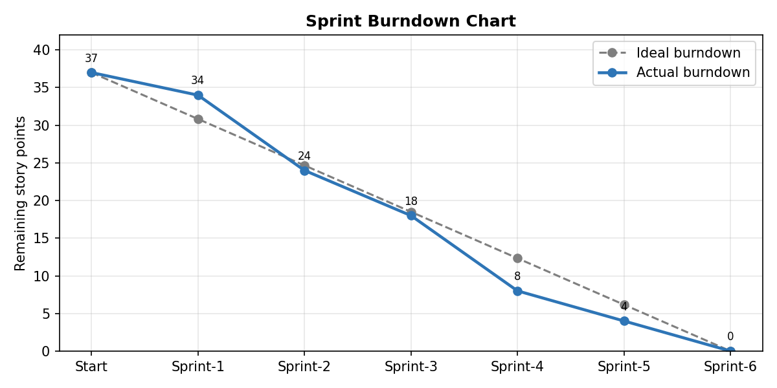
Figure 1: Sprint burndown — remaining story points against the ideal trajectory

